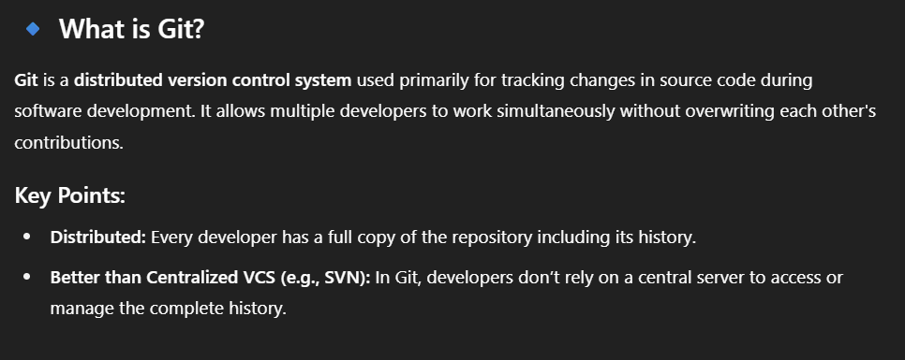

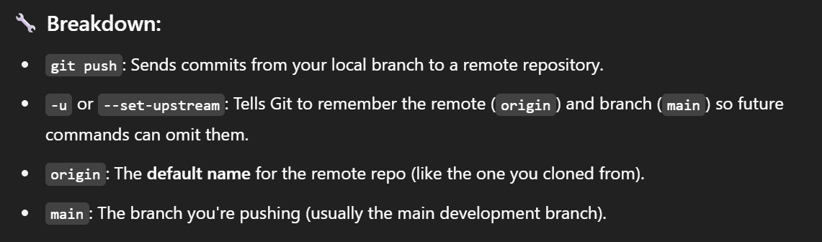

Fast-Forward merge



Three-way Merge

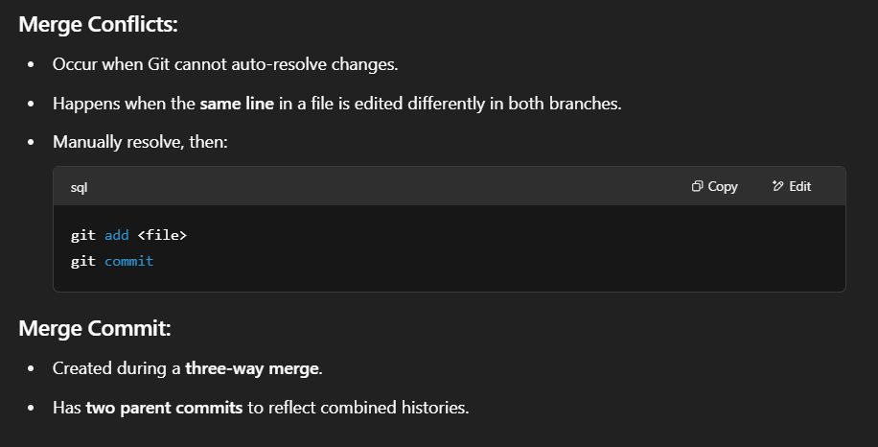

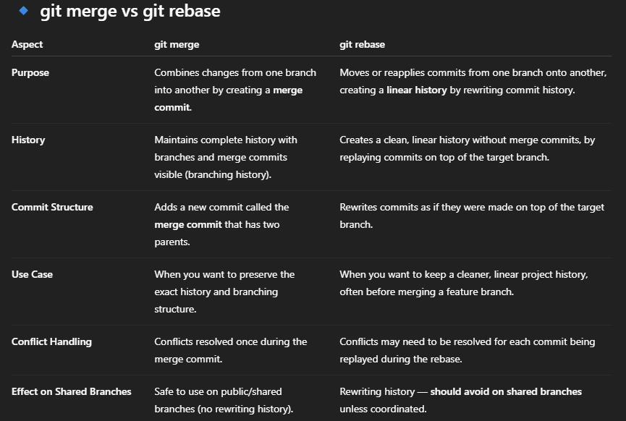

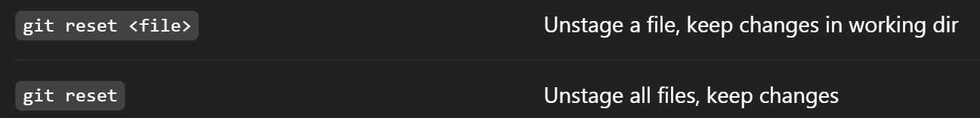

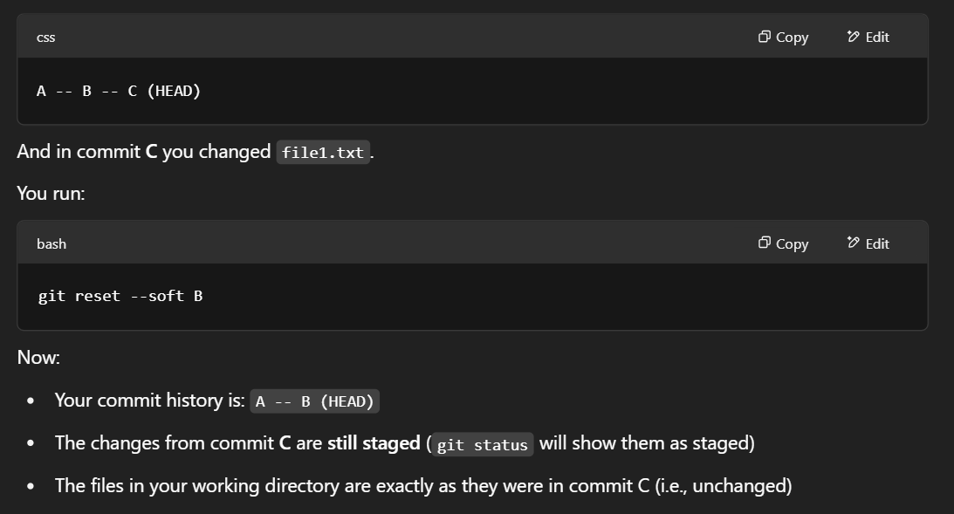

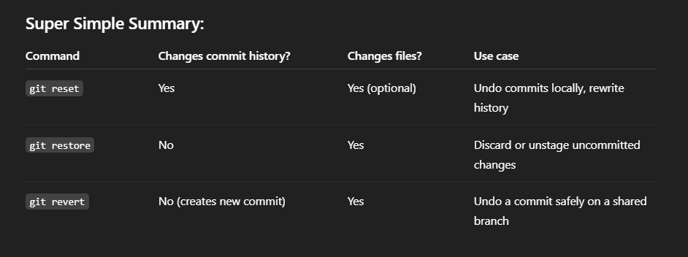

**restoring** means bringing back a previous version of a file from the Git history (usually the last committed version in your current branch), overwriting the current working version of the file.

Suppose you edited a file called index.html but haven't committed the changes yet. If you want to discard those changes and restore the file to its last committed state



Scenario based questions  
Q1. You cloned a repo and made some changes, but now you want to discard *all* local changes and go back to the latest version on origin/main.

Git restore . 🡪 It's the correct command **if** you only want to undo changes to specific files that haven't been committed yet. git restore only works on unstaged or staged changes, not on local commits.

git diff <file_name> (or leave it blank) 🡪 Shows the differences between the working directory and the staging area (or the last commit if there are no staged changes).

git –staged diff <file_name> 🡪 This flag tells Git to show the differences between the staging area and the last commit. It shows what is ready to be committed.